* **[Virtual Desktop](https://its.uiowa.edu/virtualdesktop)**

Using Virtual Desktop on Android devices

Virtual Desktop supports launching remote applications on most any kind of device, both desktop and mobile.  While it is possible to run Virtual Desktop applications on smaller devices, like an Android phone, the user experience is much better on a tablet device like a Google Nexus.  The following instructions were written for installing Citrix Receiver on an Android tablet but the instructions are fundamentally the same for an Android phone.

Installing and Using the Citrix Receiver for Android Devices

1. Open the **Google Play**store and search for **Citrix Receiver**.

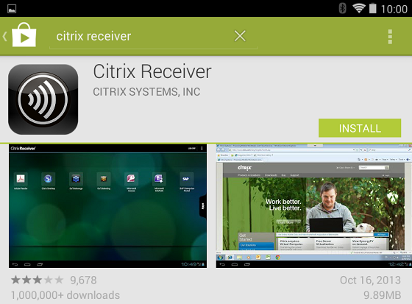

1. You may be asked to accept that Citrix Receiver needs access to various resources and will use your location.  Tap **Accept**.

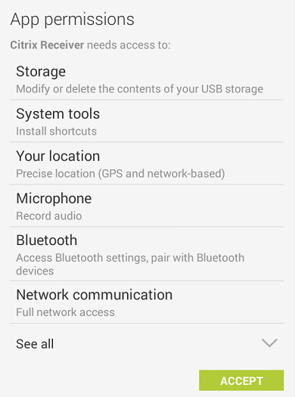

1. After installing, open Citrix Receiver and tap **Set up my enterprise apps** at the bottom.

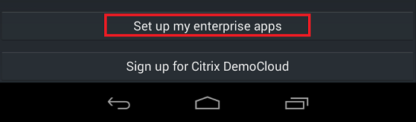

1. You need to tell Citrix Receiver the location of the Virtual Desktop service.  This is given as a web address:  [**https://virtualdesktop.uiowa.edu/citrix/virtualdesktop**](https://virtualdesktop.uiowa.edu/citrix/virtualdesktop)​.  (Note the **s** in http**s**://).  After entering the address, tap **Next**.
2. If you entered the address correctly, Virtual Desktop should appear as shown.  Tap the pencil icon at the right.

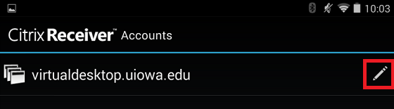

1. On the **Edit Account** screen, set **Type**to **Storefront,**enter your **username, password and domain for your HawdID**in the appropriate fields and tap **Update**.

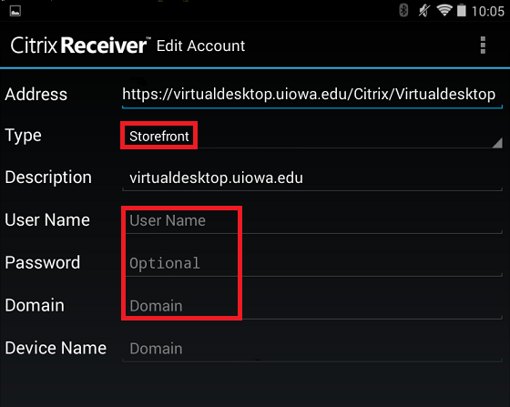

1. Citrix Receiver is now configured to connect to the Virtual Desktop service using your account.  Any favorites you've previously added on other devices will appear under the **Favorites** tab.

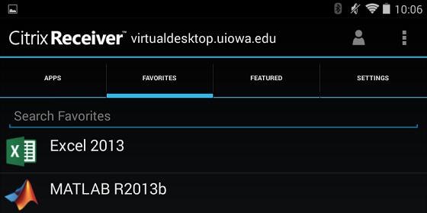

1. To find more applications, tap the **Apps**tab.  You may select them from a list or search for them to add them to your favorites.

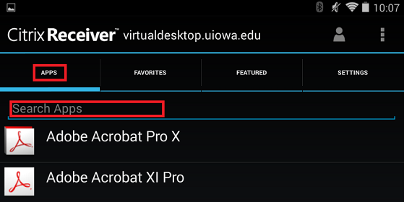

1. To launch an application, tap the **Favorites** tab and tap an application icon.